**Project 4b**

**I directly modified the Testing.py, to run the following test, just run the Testing.py.**

**Q5:**

Pen Data:

Number of training iterations for each random restart: 78, 66, 65, 81, 75

('Pen max:', 0.9116638078902229)

('Pen average:', 0.9065180102915953)

('Pen standard deviation ', 0.0037098063344787463)

Car Data:

Number of training iterations for each random restart: 93, 72, 71, 66, 84

('Car max:', 0.9073756432246999)

('Car average:', 0.905260148656375)

('Car standard deviation: ', 0.001993778819229605)

**Q6:**

*Car Data:*

Learning Curve: x-axis is the number of hidden layers, and y-axis is the average accuracy of 5 iterations.

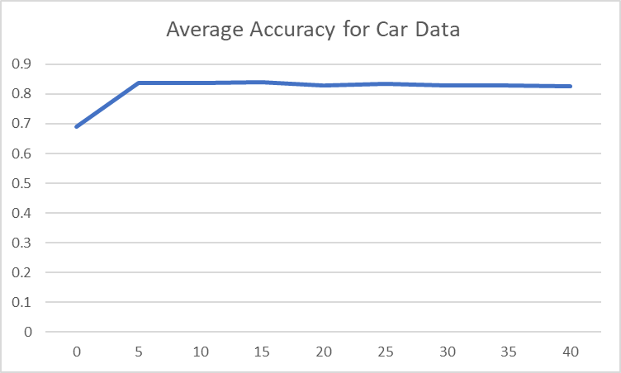

Summary Table

|  |  |  |  |  |  |  |  |  |  |
| --- | --- | --- | --- | --- | --- | --- | --- | --- | --- |
| Number of Hidden Layers | 0 | 5 | 10 | 15 | 20 | 25 | 30 | 35 | 40 |
| Max Accuracy | 0.690 | 0.859 | 0.860 | 0.854 | 0.838 | 0.840 | 0.833 | 0.838 | 0.841 |
| Average  Accuracy | 0.690 | 0.839 | 0.837 | 0.841 | 0.829 | 0.833 | 0.828 | 0.828 | 0.827 |
| Standard Deviation | 0 | 0.0133 | 0.0142 | 0.0114 | 0.0061 | 0.0060 | 0.0045 | 0.0092 | 0.0089 |

Discussion:

With the increase of the number of hidden layers from 0 to 10, the accuracy of the model increases. Because in this stage the model complexity is relatively low, and the model is in underfitting area. Increase the hidden layers will decrease the bias and therefore improve the performance.

With the increase of the number of hidden layers from 15 to 40, the accuracy decreases, because at this stage our model complexity is high enough for this problem and keep increasing will let our model suffer from overfitting. The variance of the model is increasing. Although the standard deviation is not showing this phenomenon very well (maybe it is because we only use 5 random starts). We can still see this by comparing the standard deviation of (20,25,30) with (35, 40).

*Pen Data*

Learning Curve: x-axis is the number of hidden layers, and y-axis is the average accuracy of 5 iterations.

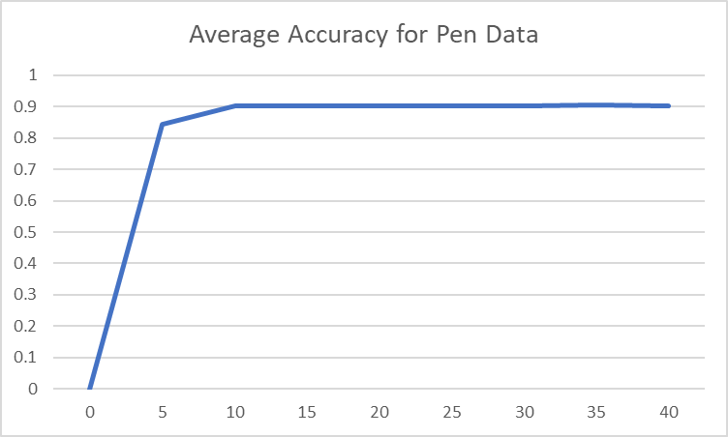

Summary Table

|  |  |  |  |  |  |  |  |  |  |
| --- | --- | --- | --- | --- | --- | --- | --- | --- | --- |
| Number of Hidden Layers | 0 | 5 | 10 | 15 | 20 | 25 | 30 | 35 | 40 |
| Max Accuracy | 0 | 0.872 | 0.925 | 0.904 | 0.907 | 0.905 | 0.908 | 0.908 | 0.909 |
| Average  Accuracy | 0 | 0.844 | 0.901 | 0.902 | 0.903 | 0.901 | 0.901 | 0.904 | 0.901 |
| Standard Deviation | 0 | 0.0165 | 0.0201 | 0.0112 | 0.0060 | 0.0031 | 0.0070 | 0.0029 | 0.0047 |

Discussion:

The overall accuracy of pen data set is better than car dataset, because pen data set have more training examples than the car data set.

If we look at the average accuracy, we can find that it increases at the first (from 0 to 10 hidden layers), because the model is in underfitting stage. Increase the hidden layers will give us a more complex model to fit the data better. However, when keep increasing the hidden layers, the accuracy doesn’t change much. Because the information of the dataset is limited. And we didn’t see the trend of overfitting in the pen data set, because the amount of data is higher than the car data, therefore the overfitting won’t occur at this stage.